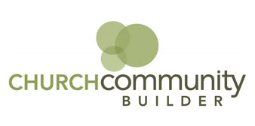
What is Church Community Builder (CCB) and why is it important for me at Simpsonville Baptist Church?

CCB is a web-based church management solution. The platform is similar to Facebook in that it focuses on profiles, groups, and self-paced community building.

It’s an online community centered around SBC, and we hope you will be able to get better connected by using group communication tools, looking for groups that may be of interest to you, and then joining one! You may also find a place to use your gifts by looking at our volunteer positions.

If you’re like most people, you meet someone at church and remember a last name, like Smith for example, but you are unsure of the first name or you can’t recall if you met the spouse or not. With CCB, you have access to a pictorial directory that will enable you to refresh your memory, as well as keep your own information up to date.
When you log in, you will be able to see all your groups, events you might be interested in, and much more. You may wish to take a moment to update your profile information to ensure our records are correct.

The online CCB site is accessible to all worship attenders regardless of membership. It offers a full directory, including photos, addresses, and phone & email information
for our church family.
Contact Angie Sanford at angie@simpsonvillebaptist.com or 722-5246 ext. 18 if you need a re-activation email sent.

Church Community Builder Login Directions

· From the activation email click on the link included which will take you to the activation page. You may change the user name if you'd prefer to use something different than your email address. Enter and confirm your password. Click Submit to save the changes.

· After entering a password, you will receive a confirmation message and be able to use the new username and password to log in.

· You will also receive an email confirming your login was created successfully.

